Equality from Similarity
# Source: AI Source: Provided by: [Data Path: Persons Table -> ID Column: 1, Name_En Column: Motasem Essam] -> From: [ChatGPT] on [7/25/2026]
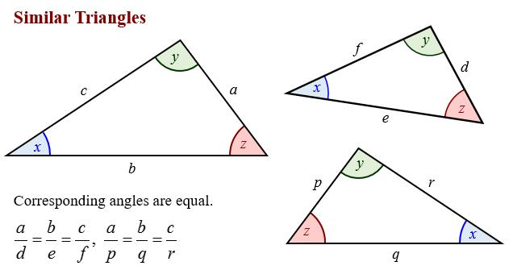
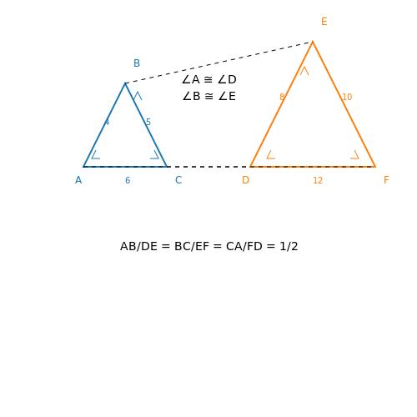
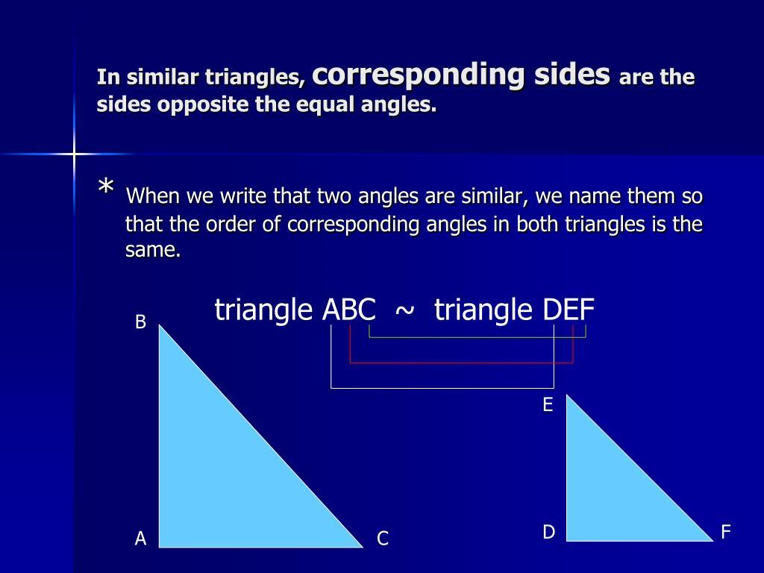
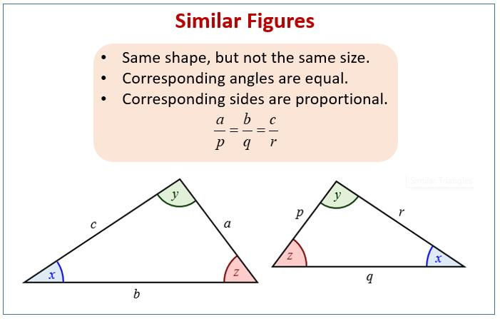
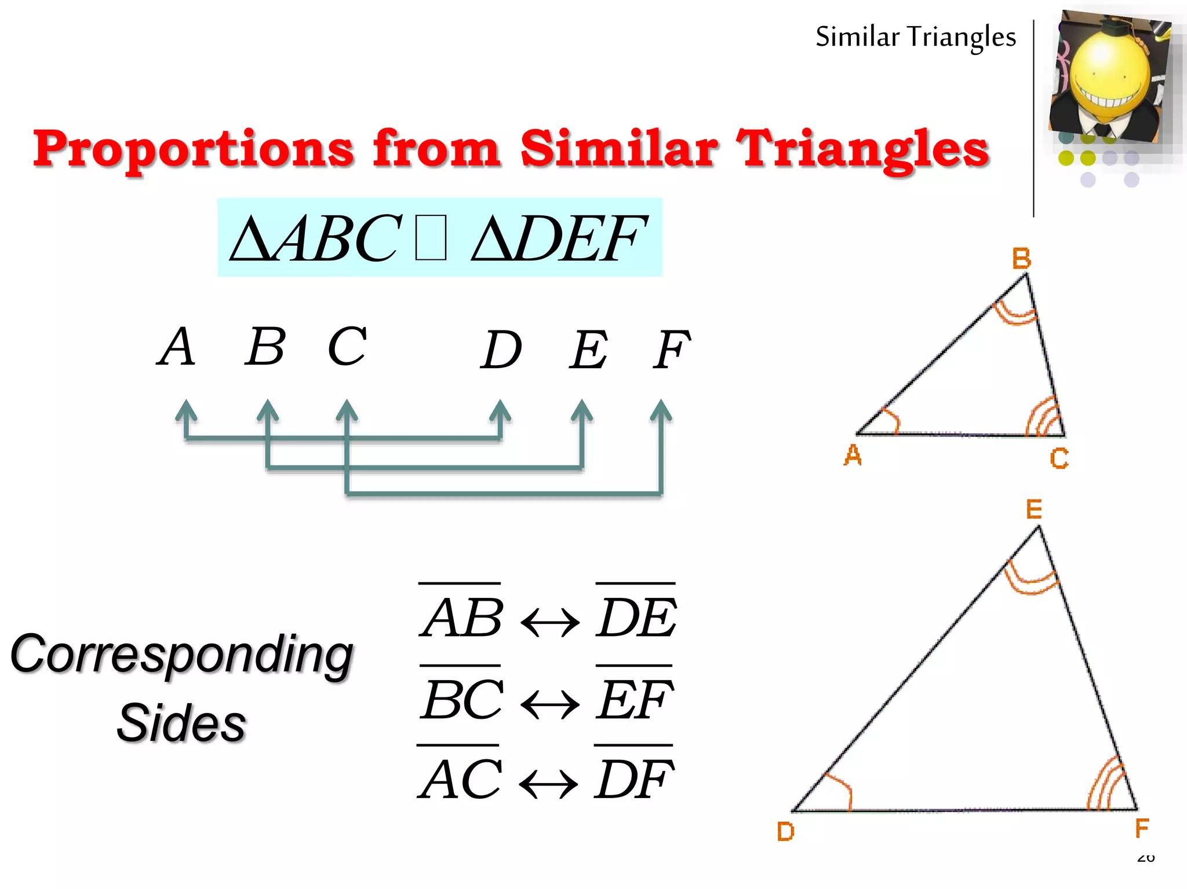
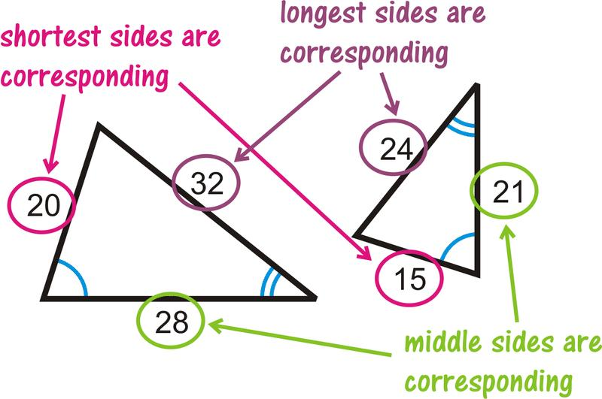

Definition
# Source: AI Source: Provided by: [Data Path: Persons Table -> ID Column: 1, Name_En Column: Motasem Essam] -> From: [ChatGPT] on [7/25/2026]
Equality from Similarity is a geometric equality obtained from a similarity relationship between geometric figures.
Similar figures have:
- the same shape,
- equal corresponding angles,
- proportional corresponding lengths.
If:
$$\boxed{F_{1}∼F_{2}}$$
then corresponding angles are equal:
$$\boxed{m∠A=m∠A^{'}}$$
and corresponding lengths are proportional:
$$\boxed{\frac{AB}{A^{'}B^{'}}=\frac{BC}{B^{'}C^{'}}=\frac{AC}{A^{'}C^{'}}}$$
However, similarity does not generally make corresponding lengths equal.

Simple Definition
# Source: AI Source: Provided by: [Data Path: Persons Table -> ID Column: 1, Name_En Column: Motasem Essam] -> From: [ChatGPT] on [7/25/2026]
Equality from Similarity means obtaining exact geometric equalities—especially angle equalities and, in the special case of scale factor $1$, length equalities—from similar figures.

Fundamental Concept
# Source: AI Source: Provided by: [Data Path: Persons Table -> ID Column: 1, Name_En Column: Motasem Essam] -> From: [ChatGPT] on [7/25/2026]
The central relationship is:
$$\boxed{\text{Similarity}→\text{Equal Corresponding Angles}+\text{Proportional Corresponding Lengths}}$$
For example:
$$△ABC∼△DEF.$$
Then:
$$\boxed{∠A=∠D} \\ \boxed{∠B=∠E} \\ \boxed{∠C=∠F}$$
while:
$$\boxed{\frac{AB}{DE}=\frac{BC}{EF}=\frac{AC}{DF}=k}$$
where $k$is the scale factor from $DEF$to $ABC$, depending on the chosen direction of the ratio.

The Most Important Distinction
# Source: AI Source: Provided by: [Data Path: Persons Table -> ID Column: 1, Name_En Column: Motasem Essam] -> From: [ChatGPT] on [7/25/2026]
Similarity produces two different kinds of relationships:
Angle Equality
$$\boxed{m∠A=m∠D}$$
Length Ratio Equality
$$\boxed{\frac{AB}{DE}=k}$$
It does not normally produce:
$$AB=DE.$$
That occurs only when:
$$\boxed{k=1}.$$
Therefore:
$$\boxed{\text{Similarity}⇒\text{Angle Equality}}$$
and:
$$\boxed{\text{Similarity}⇒\text{Ratio Equality}}$$
but:
$$\boxed{\text{Similarity}⇏\text{Length Equality}}$$
in general.

Classification of Equality from Similarity
# Source: AI Source: Provided by: [Data Path: Persons Table -> ID Column: 1, Name_En Column: Motasem Essam] -> From: [ChatGPT] on [7/25/2026]
A practical classification is:
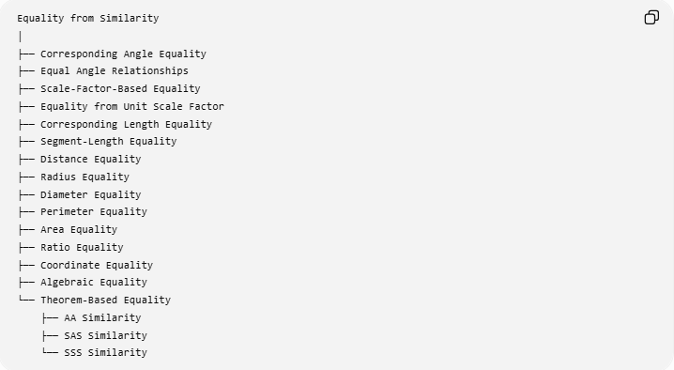
Equality from Similarity
│
├── Corresponding Angle Equality
├── Equal Angle Relationships
├── Scale-Factor-Based Equality
├── Equality from Unit Scale Factor
├── Corresponding Length Equality
├── Segment-Length Equality
├── Distance Equality
├── Radius Equality
├── Diameter Equality
├── Perimeter Equality
├── Area Equality
├── Ratio Equality
├── Coordinate Equality
├── Algebraic Equality
└── Theorem-Based Equality
├── AA Similarity
├── SAS Similarity
└── SSS Similarity
This is a practical classification, not a universally standardized formal taxonomy.

Equality of Corresponding Angles
# Source: AI Source: Provided by: [Data Path: Persons Table -> ID Column: 1, Name_En Column: Motasem Essam] -> From: [ChatGPT] on [7/25/2026]
This is the most direct equality obtained from similarity.
If:
$$△ABC∼△DEF,$$
then:
$$\boxed{m∠A=m∠D} \\ \boxed{m∠B=m∠E} \\ \boxed{m∠C=m∠F}$$
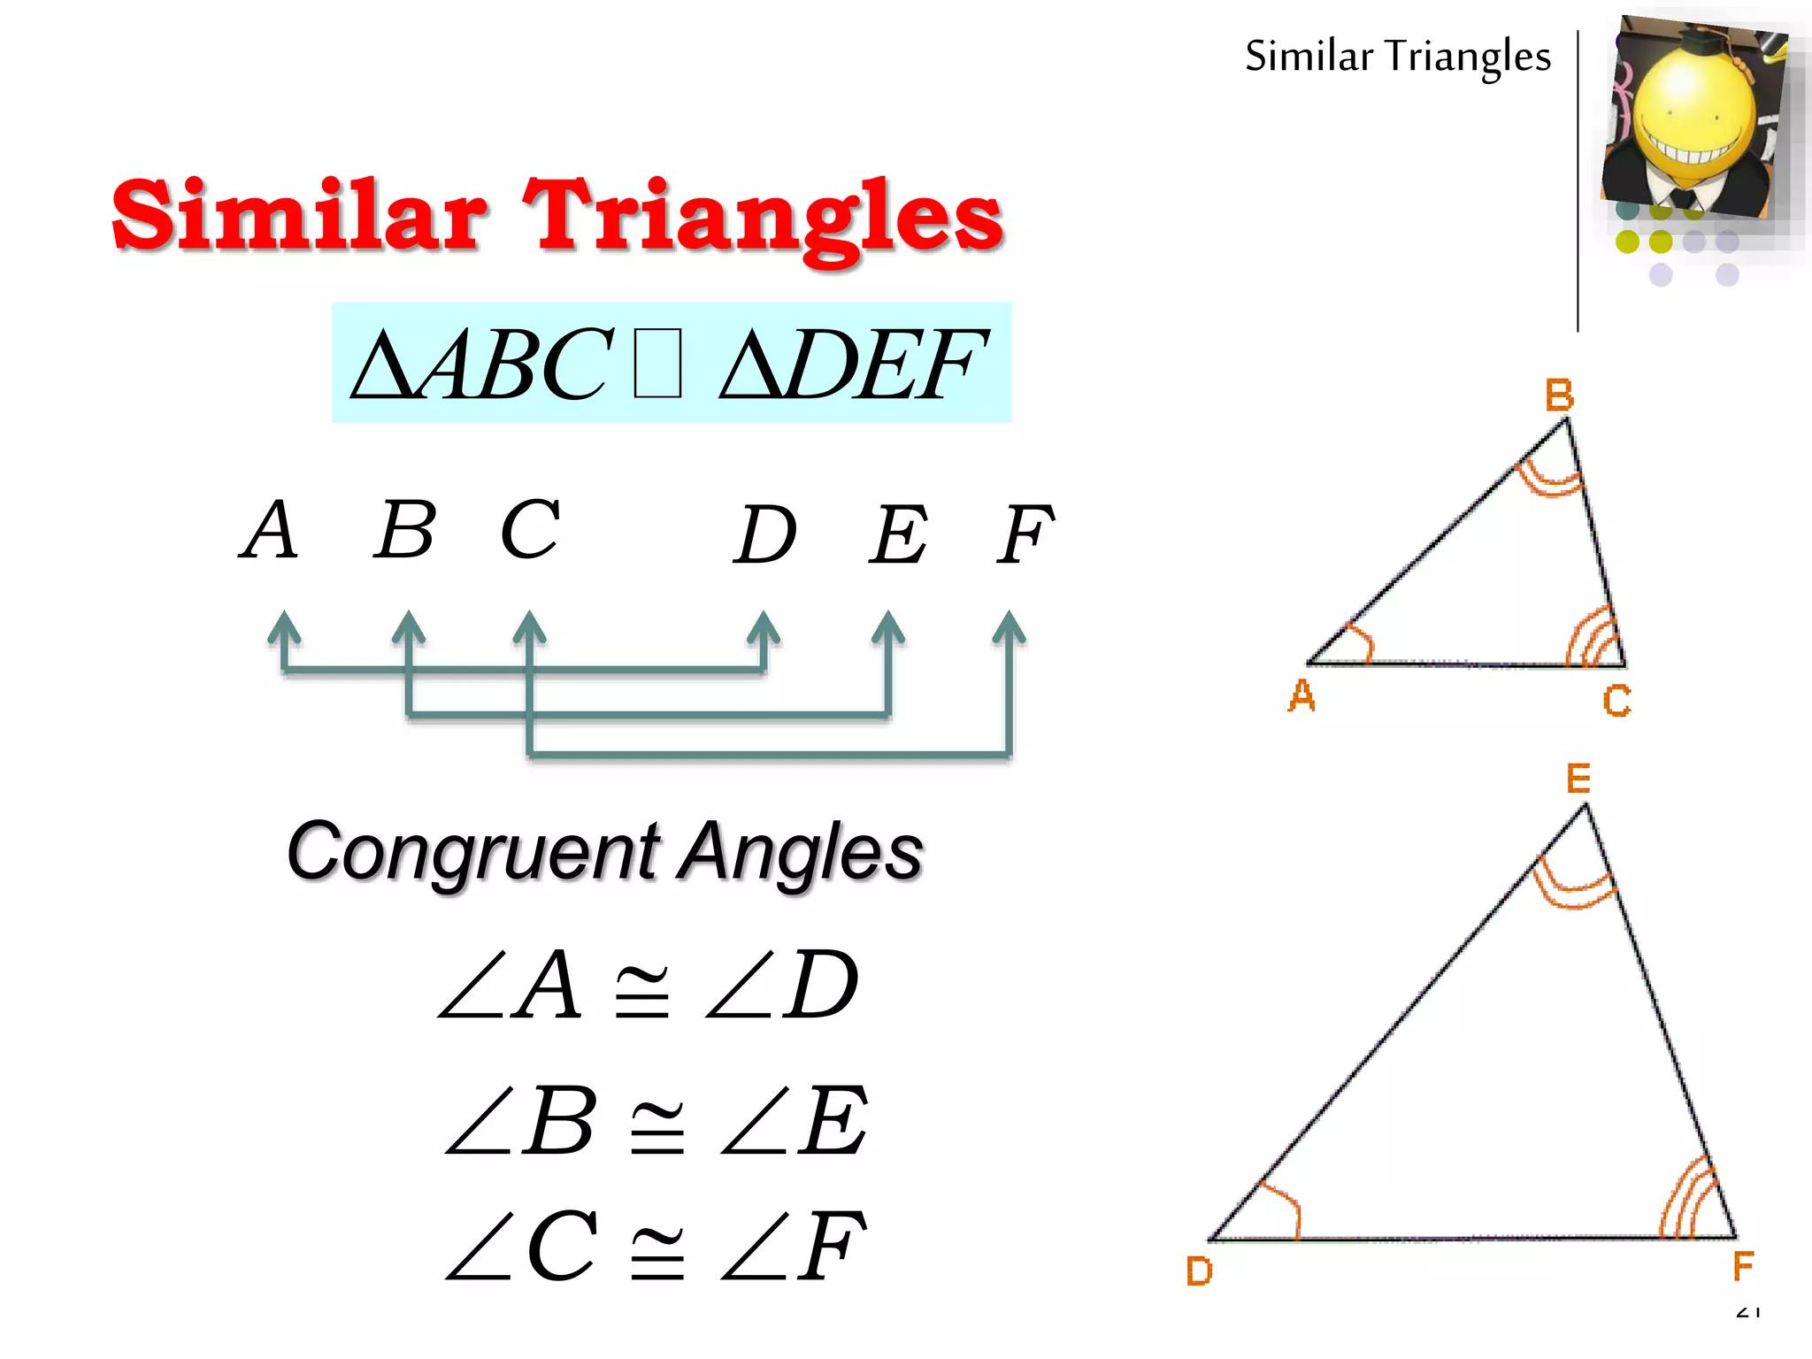
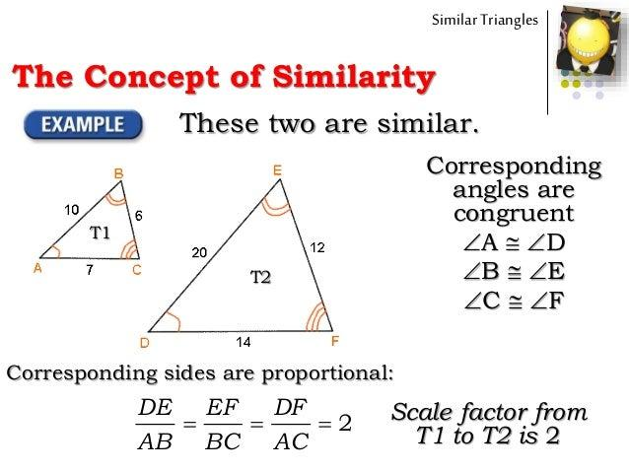
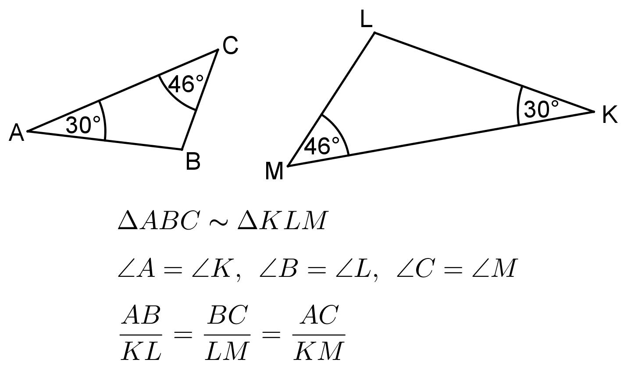
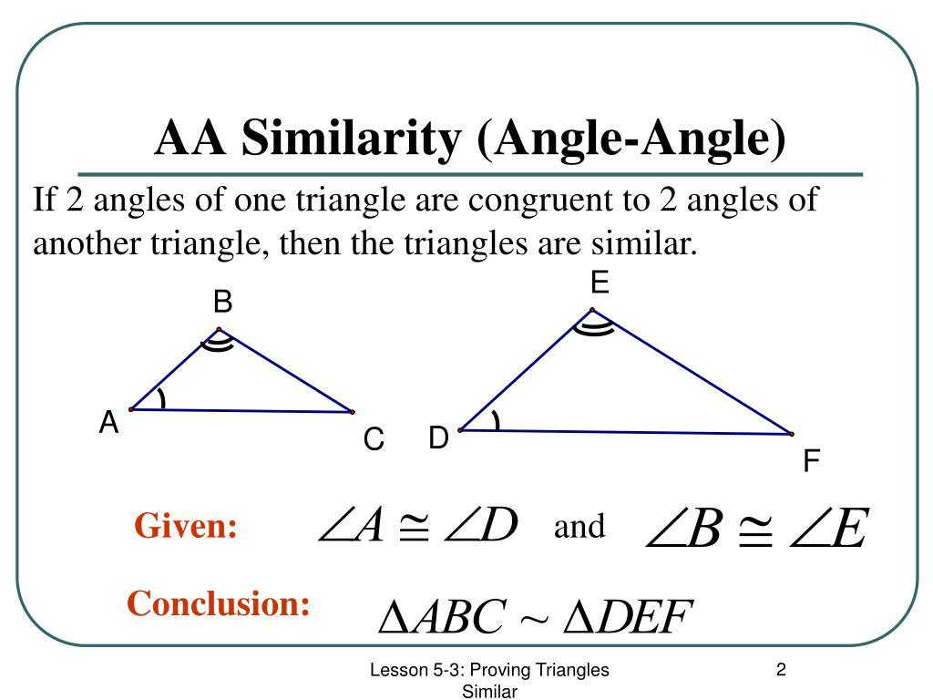
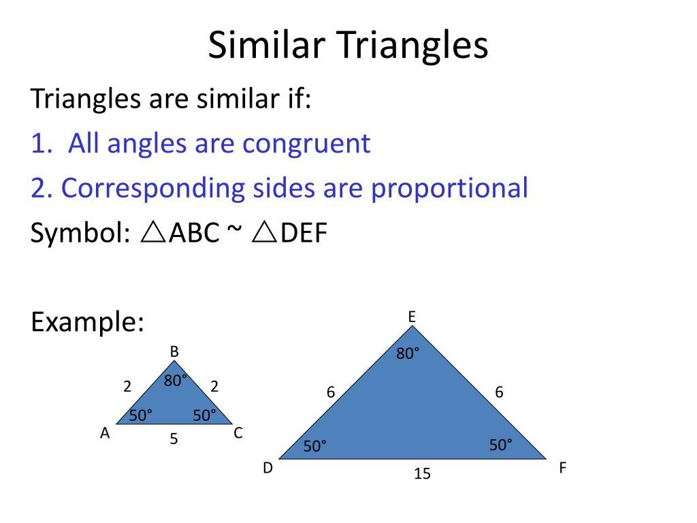
Example
If:
$$△ABC∼△DEF$$
and:
$$m∠A={40}^{∘},$$
then:
$$\boxed{m∠D={40}^{∘}}.$$

Equality of Multiple Corresponding Angles
# Source: AI Source: Provided by: [Data Path: Persons Table -> ID Column: 1, Name_En Column: Motasem Essam] -> From: [ChatGPT] on [7/25/2026]
Similarity preserves the entire angle structure of a figure.
For triangles:
$$\boxed{∠A=∠D, ∠B=∠E, ∠C=∠F}$$
Therefore, if:
$$m∠A={50}^{∘}, m∠B={60}^{∘},$$
then:
$$m∠C={70}^{∘}.$$
The corresponding triangle has:
$$\boxed{m∠D={50}^{∘}, m∠E={60}^{∘}, m∠F={70}^{∘}}.$$

Equality from AA Similarity
# Source: AI Source: Provided by: [Data Path: Persons Table -> ID Column: 1, Name_En Column: Motasem Essam] -> From: [ChatGPT] on [7/25/2026]
AA Similarity means Angle-Angle Similarity.
If two corresponding angles are equal:
$$∠A=∠D$$
and:
$$∠B=∠E,$$
then:
$$\boxed{△ABC∼△DEF}.$$
Once similarity is established, the third pair of angles is also equal:
$$\boxed{∠C=∠F}.$$
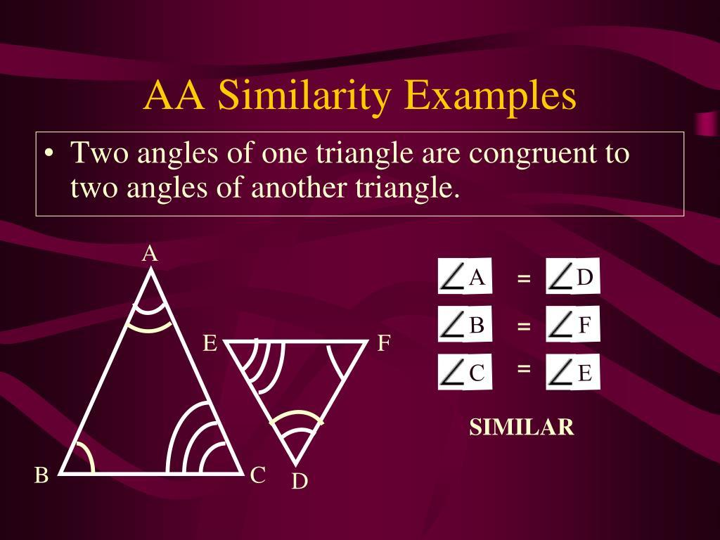
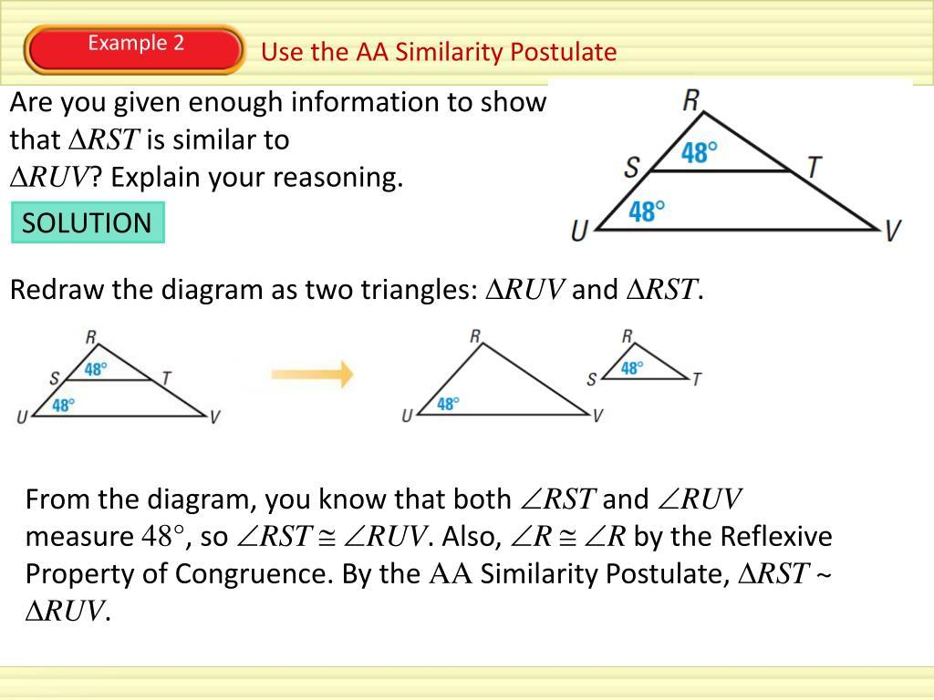
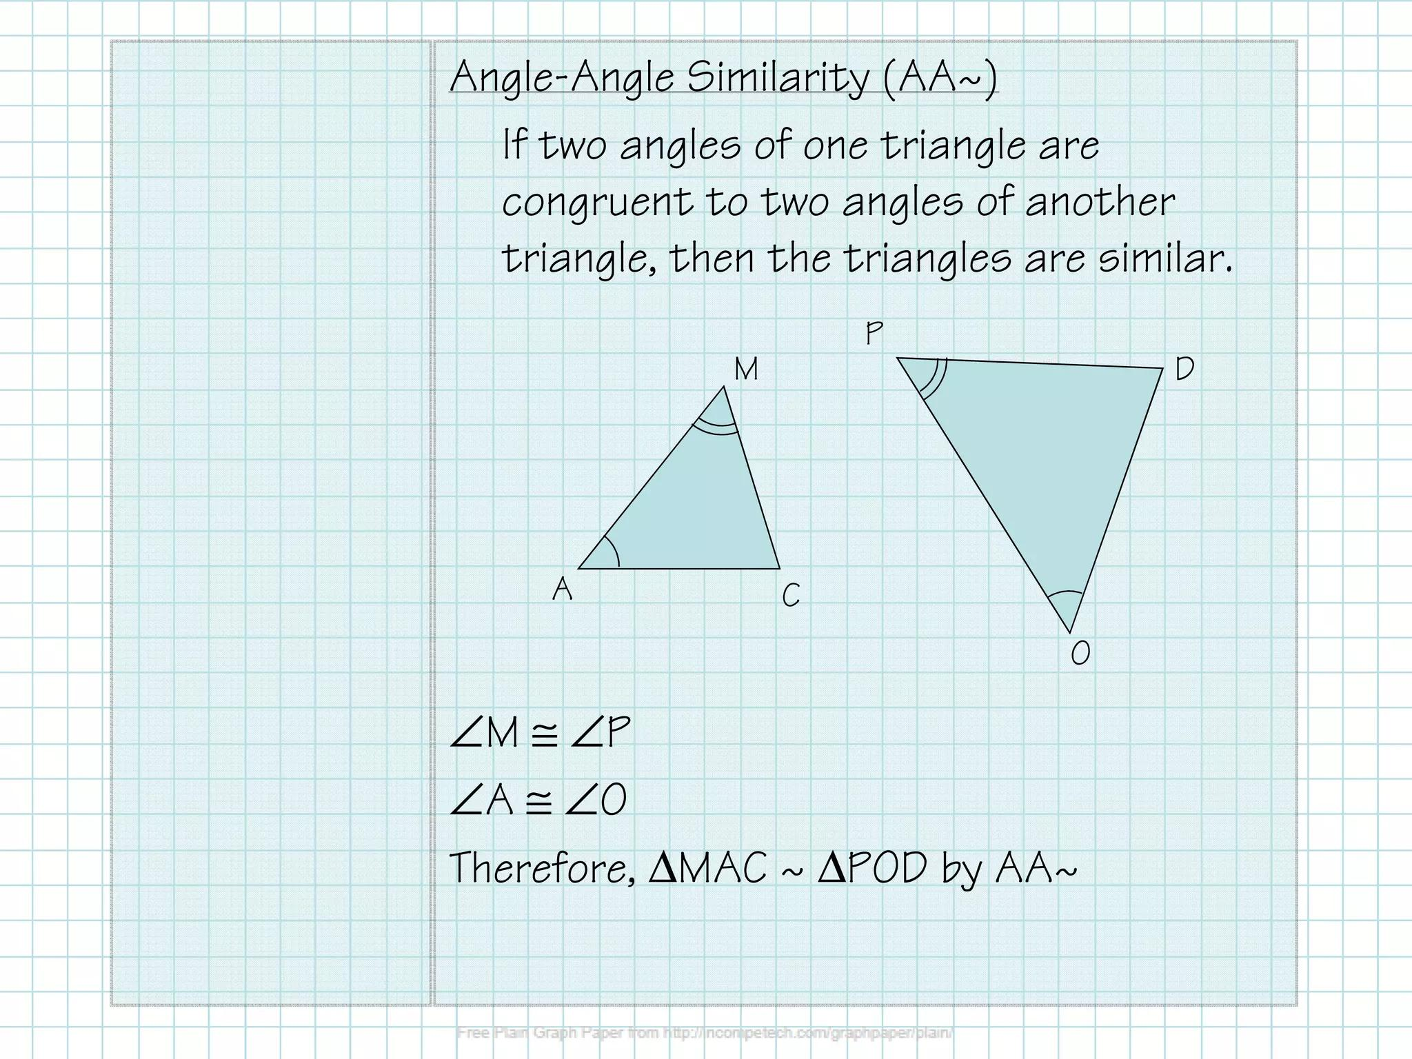
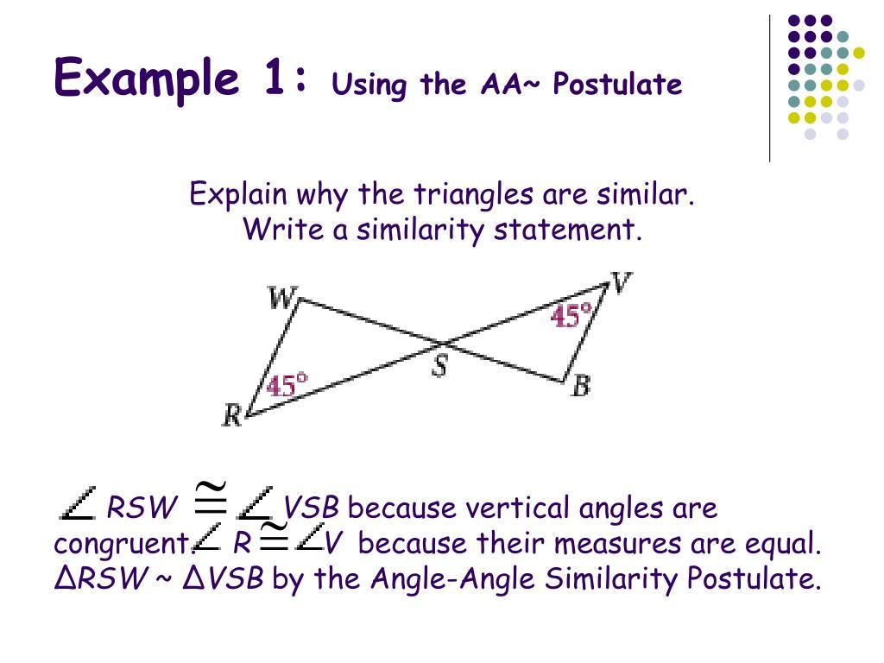

Equality from SAS Similarity
# Source: AI Source: Provided by: [Data Path: Persons Table -> ID Column: 1, Name_En Column: Motasem Essam] -> From: [ChatGPT] on [7/25/2026]
SAS Similarity uses:
- one pair of equal corresponding angles;
- proportional adjacent sides.
For example:
$$∠A=∠D$$
and:
$$\frac{AB}{DE}=\frac{AC}{DF}.$$
Therefore:
$$\boxed{△ABC∼△DEF}.$$
Similarity then establishes the remaining corresponding angle equality and side ratios.

Equality from SSS Similarity
# Source: AI Source: Provided by: [Data Path: Persons Table -> ID Column: 1, Name_En Column: Motasem Essam] -> From: [ChatGPT] on [7/25/2026]
SSS Similarity occurs when all three pairs of corresponding sides are proportional:
$$\boxed{\frac{AB}{DE}=\frac{BC}{EF}=\frac{AC}{DF}}$$
Therefore:
$$△ABC∼△DEF.$$
Consequently:
$$\boxed{∠A=∠D} \\ \boxed{∠B=∠E} \\ \boxed{∠C=∠F}.$$
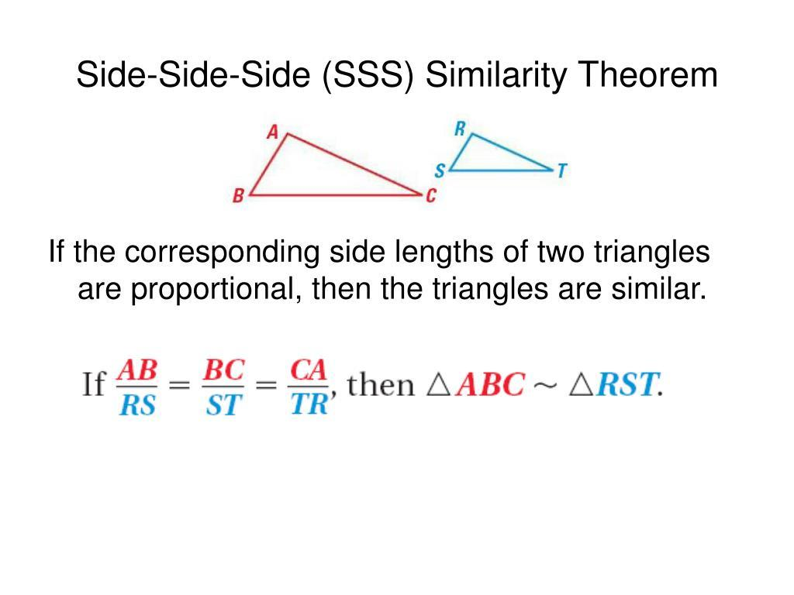
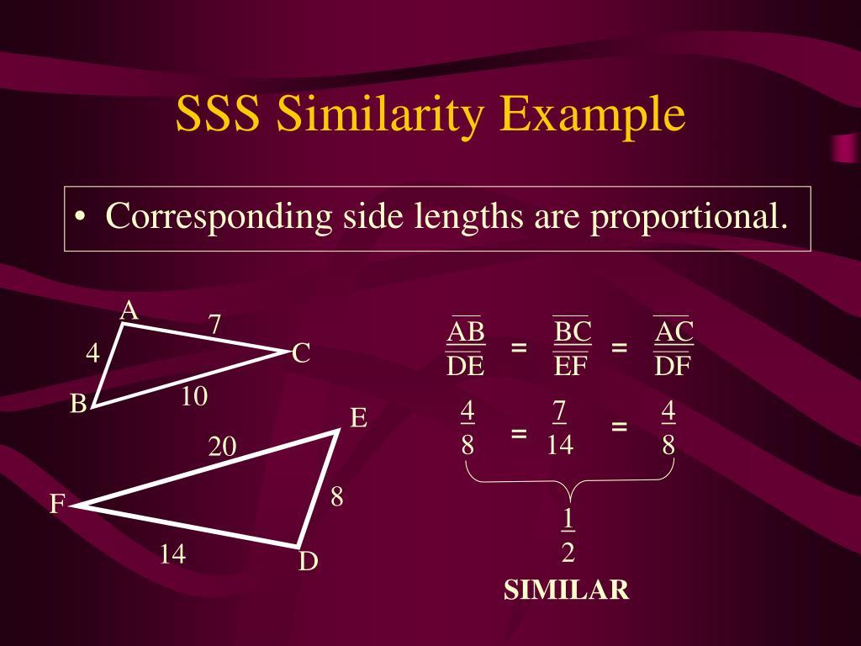
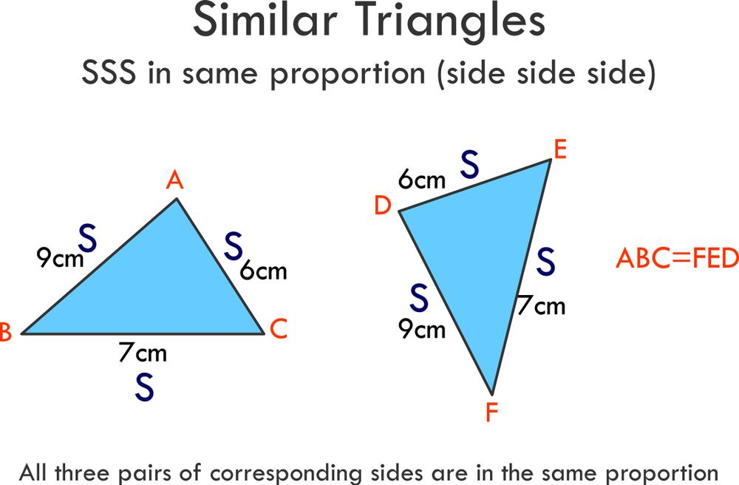
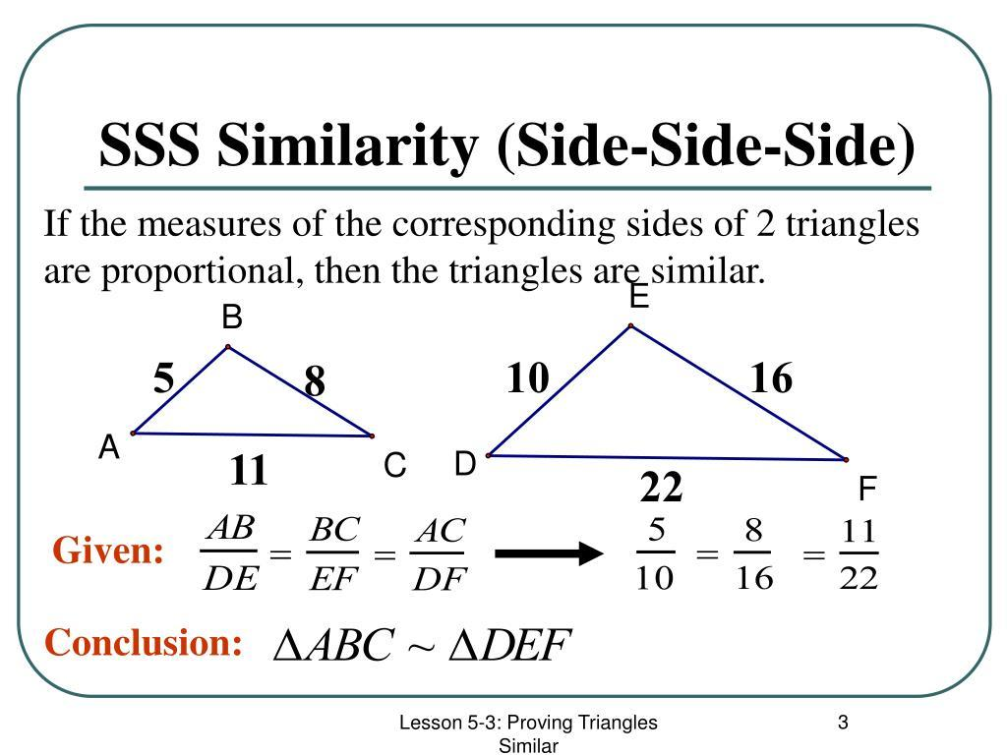
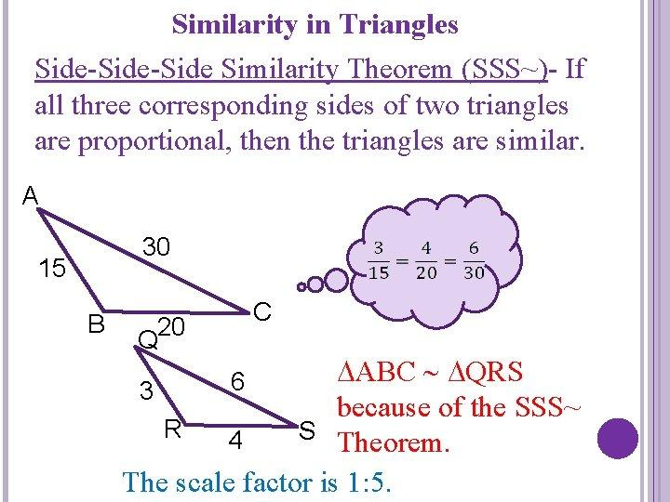

Equality from the Scale Factor
# Source: AI Source: Provided by: [Data Path: Persons Table -> ID Column: 1, Name_En Column: Motasem Essam] -> From: [ChatGPT] on [7/25/2026]
For similar figures, corresponding lengths have a constant ratio.
Let:
$$\boxed{k=\frac{\text{corresponding length in figure 2}}{\text{corresponding length in figure 1}}}.$$
Then every corresponding linear dimension has the same ratio.
For example:
$$\frac{DE}{AB}=\frac{EF}{BC}=\frac{DF}{AC}=k.$$
Example
Suppose:
$$AB=5, DE=10.$$
Then:
$$k=\frac{10}{5}=2.$$
If:
$$BC=7,$$
then:
$$EF=14.$$
Thus:
$$\frac{DE}{AB}=\frac{EF}{BC}=2.$$

Equality from a Unit Scale Factor
# Source: AI Source: Provided by: [Data Path: Persons Table -> ID Column: 1, Name_En Column: Motasem Essam] -> From: [ChatGPT] on [7/25/2026]
This is the special case where similarity produces actual equality of corresponding lengths.
If:
$$\boxed{k=1},$$
then:
$$\frac{AB}{DE}=1.$$
Therefore:
$$\boxed{AB=DE}.$$
Thus:
$$\boxed{\text{Similarity}+k=1⇒\text{Corresponding Length Equality}}$$
For ordinary Euclidean figures, similarity with scale factor $1$gives congruence.
$$\boxed{\text{Similarity with }k=1⇒\text{Congruence}}$$
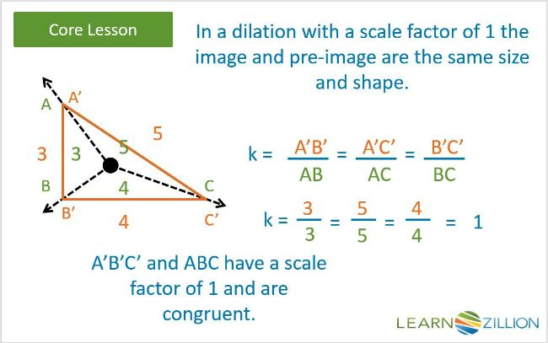
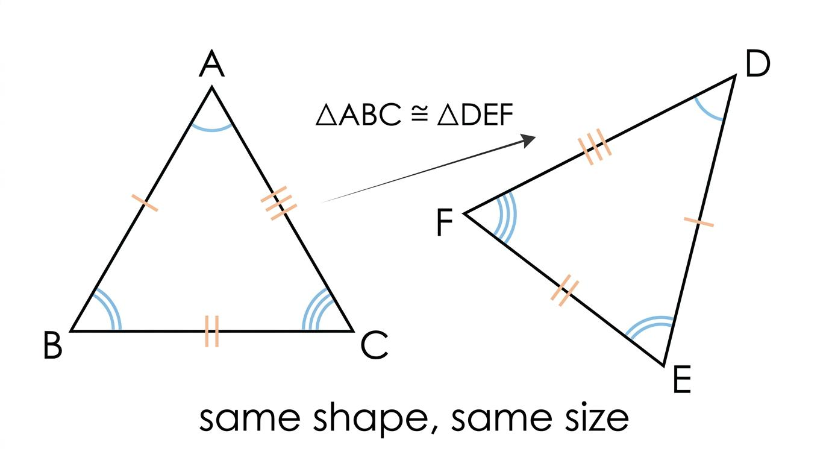

Corresponding Length Equality
# Source: AI Source: Provided by: [Data Path: Persons Table -> ID Column: 1, Name_En Column: Motasem Essam] -> From: [ChatGPT] on [7/25/2026]
Suppose:
$$F_{1}∼F_{2}$$
with:
$$k=1.$$
Then:
$$\boxed{AB=A^{'}B^{'}}$$
for every corresponding segment.
Example
Two similar triangles have:
$$AB=8, DE=8.$$
Then:
$$\frac{DE}{AB}=1.$$
Therefore their corresponding lengths are equal.

Segment-Length Equality from Similarity
# Source: AI Source: Provided by: [Data Path: Persons Table -> ID Column: 1, Name_En Column: Motasem Essam] -> From: [ChatGPT] on [7/25/2026]
Similarity alone generally gives:
$$\frac{AB}{DE}=k.$$
If $k=1$:
$$AB=DE.$$
Example
If two similar rectangles have corresponding lengths:
$$l_{1}=12, l_{2}=12$$
and:
$$w_{1}=7, w_{2}=7,$$
then:
$$\boxed{l_{1}=l_{2}}$$
and:
$$\boxed{w_{1}=w_{2}}.$$
The figures are congruent.

Distance Equality from Similarity
# Source: AI Source: Provided by: [Data Path: Persons Table -> ID Column: 1, Name_En Column: Motasem Essam] -> From: [ChatGPT] on [7/25/2026]
Distances scale by the same linear scale factor.
If:
$$F_{1}∼F_{2}$$
with scale factor $k$, then corresponding distances satisfy:
$$\boxed{d_{2}=kd_{1}}.$$
If:
$$k=1,$$
then:
$$\boxed{d_{1}=d_{2}}.$$
Example
Two similar configurations have corresponding distances:
$$d_{1}=10, d_{2}=10.$$
Since:
$$k=\frac{10}{10}=1,$$
the corresponding distances are equal.

Radius Equality from Similarity
# Source: AI Source: Provided by: [Data Path: Persons Table -> ID Column: 1, Name_En Column: Motasem Essam] -> From: [ChatGPT] on [7/25/2026]
For similar circles, radii are proportional:
$$\boxed{\frac{r_{2}}{r_{1}}=k}.$$
If:
$$k=1,$$
then:
$$\boxed{r_{1}=r_{2}}.$$
Example
Two circles have radii:
$$r_{1}=6, r_{2}=6.$$
Then:
$$\frac{r_{2}}{r_{1}}=1.$$
Therefore:
$$\boxed{r_{1}=r_{2}}.$$
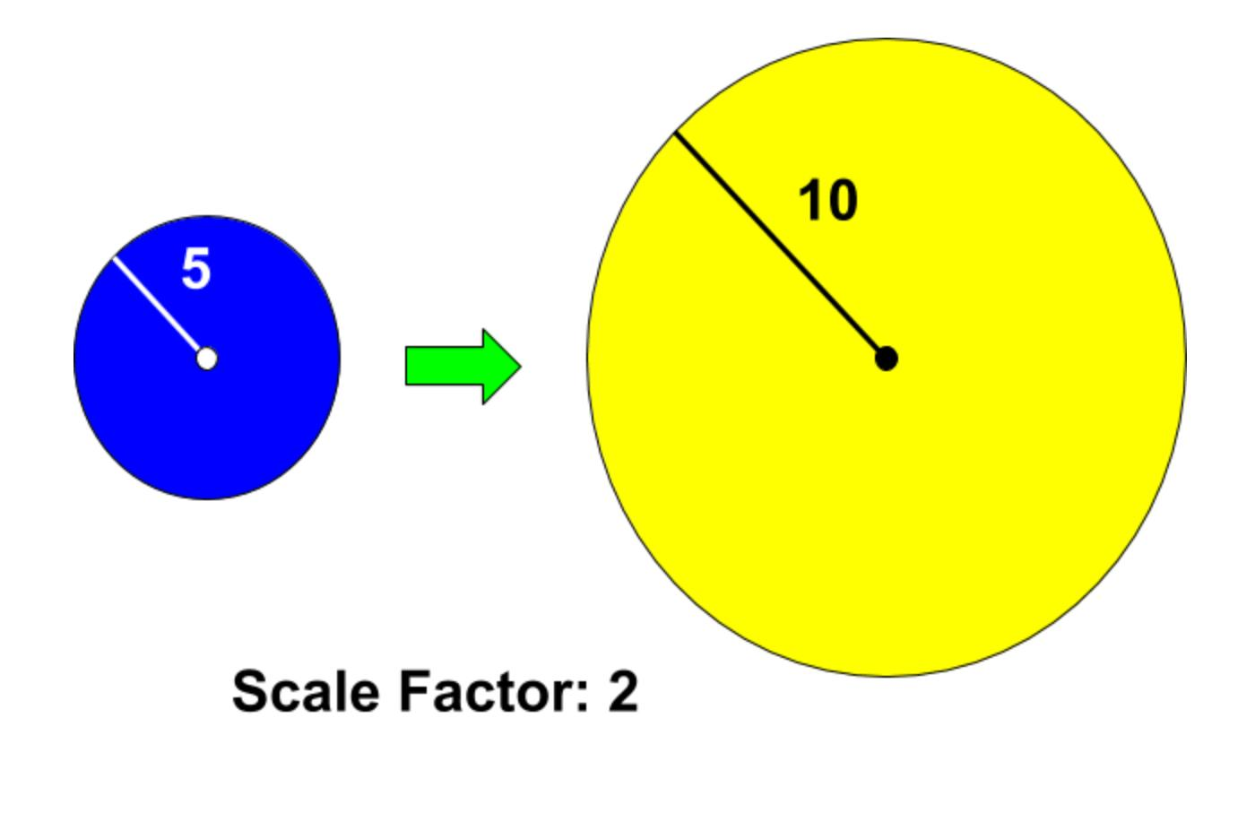
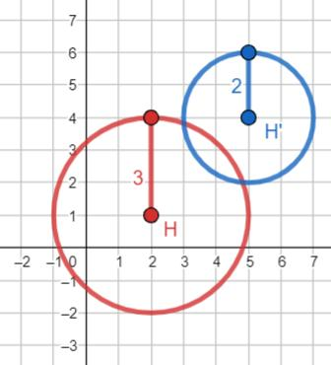
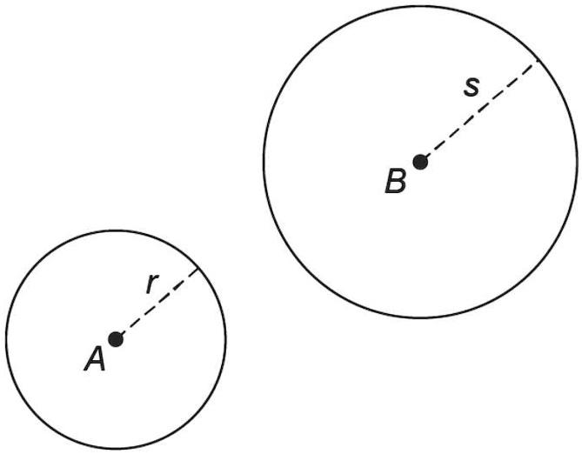

Diameter Equality from Similarity
# Source: AI Source: Provided by: [Data Path: Persons Table -> ID Column: 1, Name_En Column: Motasem Essam] -> From: [ChatGPT] on [7/25/2026]
Diameters also scale linearly:
$$\boxed{d_{2}=kd_{1}}.$$
If:
$$k=1,$$
then:
$$\boxed{d_{1}=d_{2}}.$$
Since:
$$d=2r,$$
radius and diameter equality occur together.

Perimeter Equality from Similarity
# Source: AI Source: Provided by: [Data Path: Persons Table -> ID Column: 1, Name_En Column: Motasem Essam] -> From: [ChatGPT] on [7/25/2026]
For similar figures:
$$\boxed{\frac{P_{2}}{P_{1}}=k}$$
because perimeter is a sum of lengths.
If:
$$k=1,$$
then:
$$\boxed{P_{1}=P_{2}}.$$
Example
Two similar polygons have:
$$P_{1}=30, P_{2}=30.$$
Then:
$$k=\frac{30}{30}=1.$$
Thus their corresponding lengths are also equal.

Area Equality from Similarity
# Source: AI Source: Provided by: [Data Path: Persons Table -> ID Column: 1, Name_En Column: Motasem Essam] -> From: [ChatGPT] on [7/25/2026]
Area does not scale by $k$. It scales by:
$$\boxed{k^{2}}.$$
For similar figures:
$$\boxed{\frac{A_{2}}{A_{1}}=k^{2}}$$
Therefore, area equality requires:
$$A_{1}=A_{2}.$$
So:
$$k^{2}=1.$$
For ordinary positive scale factors:
$$\boxed{k=1}.$$
Thus:
$$\boxed{\text{Similar figures with equal areas are congruent}}$$
under the usual nondegenerate Euclidean setting.
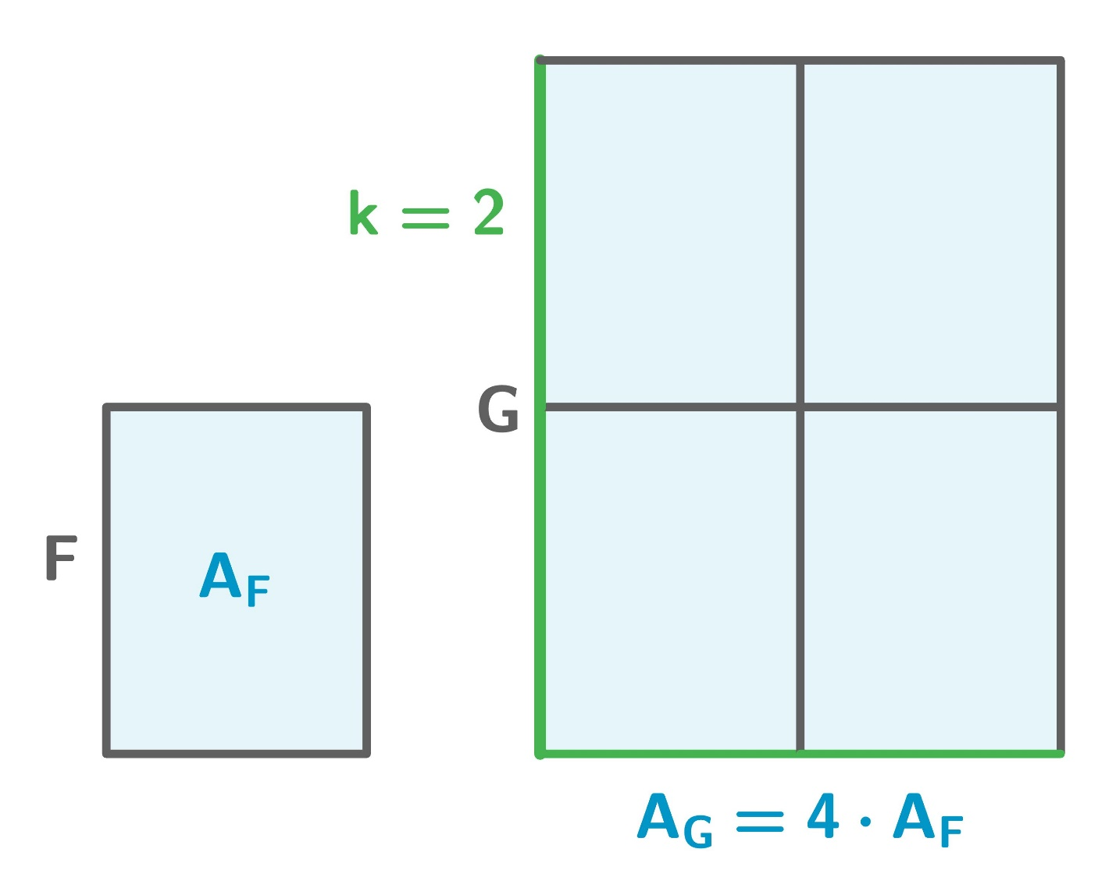
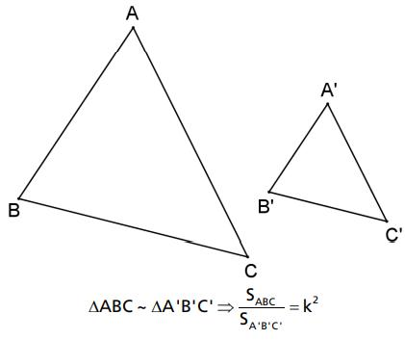
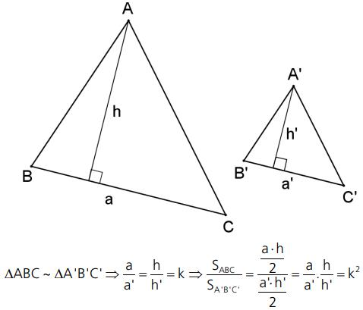
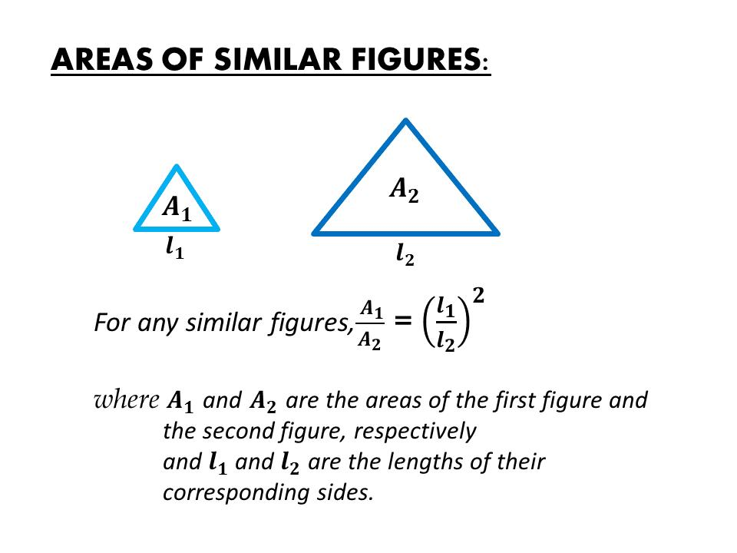
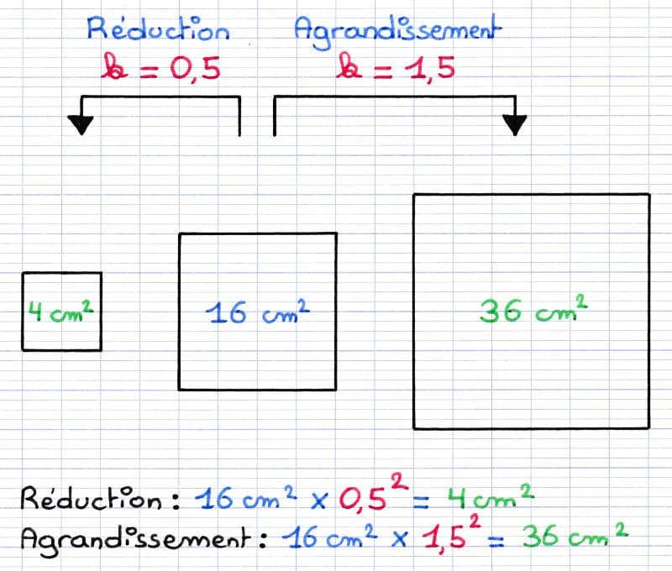

Ratio Equality from Similarity
# Source: AI Source: Provided by: [Data Path: Persons Table -> ID Column: 1, Name_En Column: Motasem Essam] -> From: [ChatGPT] on [7/25/2026]
Similarity naturally produces Ratio Equality.
For:
$$△ABC∼△DEF,$$
we have:
$$\boxed{\frac{AB}{DE}=\frac{BC}{EF}=\frac{AC}{DF}}.$$
This is one of the most important relationships between Equality from Similarity and Ratio Equality.
Example
If:
$$AB=4, BC=6, AC=8$$
and:
$$DE=6, EF=9, DF=12,$$
then:
$$\frac{4}{6}=\frac{6}{9}=\frac{8}{12}=\frac{2}{3}.$$
Therefore:
$$\boxed{\frac{AB}{DE}=\frac{BC}{EF}=\frac{AC}{DF}}.$$
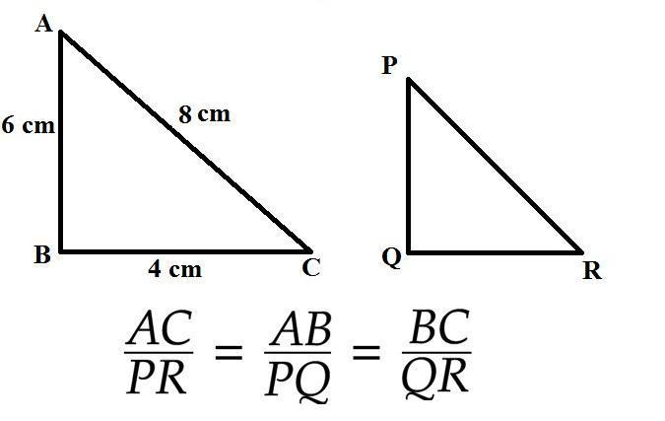
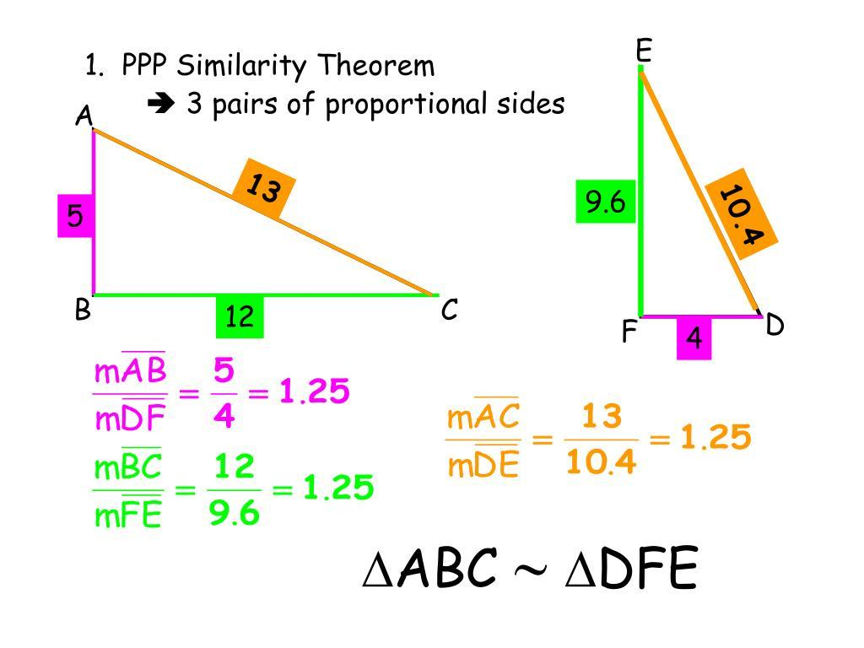

Equality of Perimeters and Length Ratios
# Source: AI Source: Provided by: [Data Path: Persons Table -> ID Column: 1, Name_En Column: Motasem Essam] -> From: [ChatGPT] on [7/25/2026]
Suppose:
$$\frac{P_{2}}{P_{1}}=k.$$
If:
$$k=1,$$
then:
$$P_{2}=P_{1}.$$
But if:
$$k=2,$$
then:
$$P_{2}=2P_{1}.$$
Example
$$P_{1}=20, P_{2}=40.$$
Then:
$$\frac{P_{2}}{P_{1}}=2.$$
The figures are similar, but their perimeters are not equal.

Equality of Areas and Length Ratios
# Source: AI Source: Provided by: [Data Path: Persons Table -> ID Column: 1, Name_En Column: Motasem Essam] -> From: [ChatGPT] on [7/25/2026]
Suppose two similar figures have:
$$k=2.$$
Then their areas satisfy:
$$\frac{A_{2}}{A_{1}}=2^{2}=4.$$
Thus:
$$A_{2}=4A_{1}.$$
Their areas are not equal.
This demonstrates why:
$$\boxed{\text{Similarity}⇏\text{Area Equality}}$$
in general.

Equality from Similarity in Nested Triangles
# Source: AI Source: Provided by: [Data Path: Persons Table -> ID Column: 1, Name_En Column: Motasem Essam] -> From: [ChatGPT] on [7/25/2026]
Similarity frequently occurs in triangles created by parallel lines.
Suppose:
$$DE∥BC$$
inside $△ABC$.
Then:
$$△ADE∼△ABC.$$
Therefore:
$$\boxed{∠A=∠A}$$
and corresponding angles are equal, while:
$$\boxed{\frac{AD}{AB}=\frac{AE}{AC}=\frac{DE}{BC}}.$$
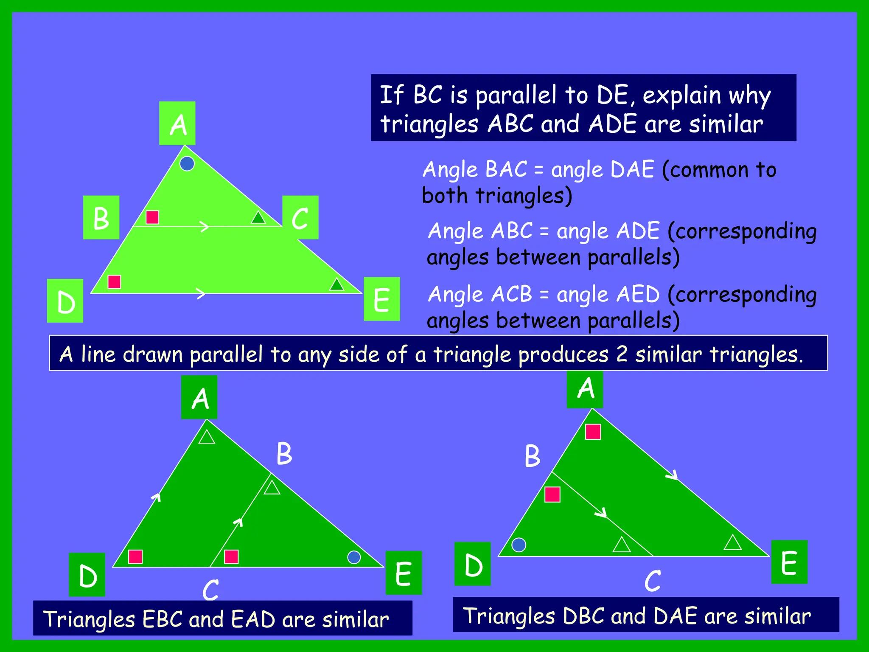
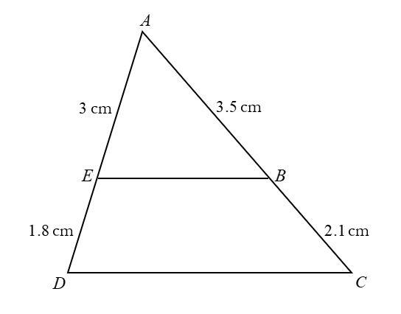
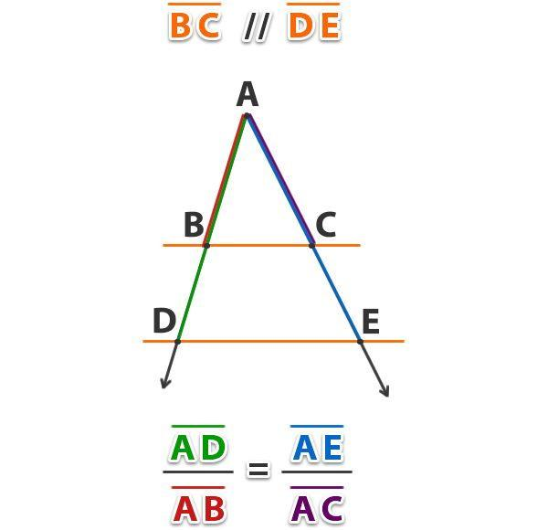
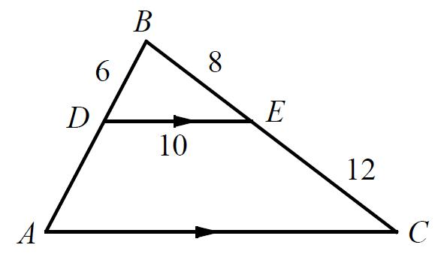

Equality from Similarity and Algebra
# Source: AI Source: Provided by: [Data Path: Persons Table -> ID Column: 1, Name_En Column: Motasem Essam] -> From: [ChatGPT] on [7/25/2026]
Similarity often creates equations involving proportional lengths.
Suppose:
$$△ABC∼△DEF$$
and:
$$AB=6, DE=9.$$
Suppose:
$$BC=x, EF=12.$$
Then:
$$\frac{AB}{DE}=\frac{BC}{EF}.$$
Therefore:
$$\frac{6}{9}=\frac{x}{12}.$$
Simplify:
$$\frac{2}{3}=\frac{x}{12}.$$
Thus:
$$3x=24 \\ \boxed{x=8}.$$
So:
$$\boxed{BC=8}.$$

Equality from Similarity in Coordinate Geometry
# Source: AI Source: Provided by: [Data Path: Persons Table -> ID Column: 1, Name_En Column: Motasem Essam] -> From: [ChatGPT] on [7/25/2026]
Coordinates can establish similarity and then corresponding equality.
For example, if two triangles have corresponding side lengths:
$$AB=5, BC=7, AC=8$$
and:
$$DE=5, EF=7, DF=8,$$
then:
$$\frac{AB}{DE}=\frac{BC}{EF}=\frac{AC}{DF}=1.$$
Therefore:
$$k=1.$$
Thus the corresponding lengths are equal and the triangles are congruent.

Similarity vs Congruence
# Source: AI Source: Provided by: [Data Path: Persons Table -> ID Column: 1, Name_En Column: Motasem Essam] -> From: [ChatGPT] on [7/25/2026]
This distinction is essential.
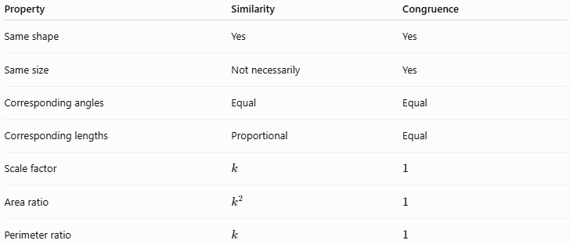
Property | Similarity | Congruence
Same shape | Yes | Yes
Same size | Not necessarily | Yes
Corresponding angles | Equal | Equal
Corresponding lengths | Proportional | Equal
Scale factor | $$k$$ | $$1$$
Area ratio | $$k^{2}$$ | $$1$$
Perimeter ratio | $$k$$ | $$1$$
Therefore:
$$\boxed{\text{Congruence is the }k=1\text{ case of similarity}}$$
in ordinary Euclidean geometry.

Similarity vs Ratio Equality
# Source: AI Source: Provided by: [Data Path: Persons Table -> ID Column: 1, Name_En Column: Motasem Essam] -> From: [ChatGPT] on [7/25/2026]
Similarity and Ratio Equality are closely connected.
Similarity
$$△ABC∼△DEF$$
is a relationship between figures.
Ratio Equality
$$\frac{AB}{DE}=\frac{BC}{EF}=\frac{AC}{DF}$$
is a relationship between quantities.
Thus:
$$\boxed{\text{Similarity}⇒\text{Corresponding Ratio Equality}}$$
but a single ratio equality does not generally establish similarity.

Similarity vs Angle Equality
# Source: AI Source: Provided by: [Data Path: Persons Table -> ID Column: 1, Name_En Column: Motasem Essam] -> From: [ChatGPT] on [7/25/2026]
Similarity always gives corresponding angle equality:
$$\boxed{△ABC∼△DEF⇒∠A=∠D}$$
But one pair of equal angles alone does not establish triangle similarity.
For AA similarity, two corresponding angle equalities are sufficient:
$$\boxed{∠A=∠D \text{and} ∠B=∠E⇒△ABC∼△DEF}$$

Important Scaling Relationships
# Source: AI Source: Provided by: [Data Path: Persons Table -> ID Column: 1, Name_En Column: Motasem Essam] -> From: [ChatGPT] on [7/25/2026]
For similar figures with scale factor $k$:
Length
$$\boxed{L_{2}=kL_{1}}$$
Distance
$$\boxed{d_{2}=kd_{1}}$$
Radius
$$\boxed{r_{2}=kr_{1}}$$
Diameter
$$\boxed{d_{2}=kd_{1}}$$
Perimeter
$$\boxed{P_{2}=kP_{1}}$$
Area
$$\boxed{A_{2}=k^{2}A_{1}}$$
Volume
For similar three-dimensional solids:
$$\boxed{V_{2}=k^{3}V_{1}}.$$
Therefore, equality of any of these corresponding quantities generally requires:
$$\boxed{k=1}$$
for positive, nondegenerate figures.

Equality from Similarity in a Proof
# Source: AI Source: Provided by: [Data Path: Persons Table -> ID Column: 1, Name_En Column: Motasem Essam] -> From: [ChatGPT] on [7/25/2026]
Given
$$△ABC∼△DEF$$
Prove
$$∠B=∠E.$$
Proof
Because:
$$△ABC∼△DEF,$$
the correspondence is:
$$A↔D, B↔E, C↔F.$$
Therefore, corresponding angles are equal:
$$\boxed{∠B=∠E}.$$

Another Proof Example
# Source: AI Source: Provided by: [Data Path: Persons Table -> ID Column: 1, Name_En Column: Motasem Essam] -> From: [ChatGPT] on [7/25/2026]
Given
$$△ABC∼△DEF$$
and:
$$AB=DE.$$
Prove
$$BC=EF.$$
Similarity gives:
$$\frac{AB}{DE}=\frac{BC}{EF}.$$
Since:
$$AB=DE,$$
we have:
$$\frac{AB}{DE}=1.$$
Therefore:
$$\frac{BC}{EF}=1.$$
Hence:
$$\boxed{BC=EF}.$$
This illustrates an important principle:
$$\boxed{\text{Similarity}+\text{one corresponding length equality}⇒\text{scale factor }1⇒\text{all corresponding lengths equal}}$$

Classification Summary
# Source: AI Source: Provided by: [Data Path: Persons Table -> ID Column: 1, Name_En Column: Motasem Essam] -> From: [ChatGPT] on [7/25/2026]
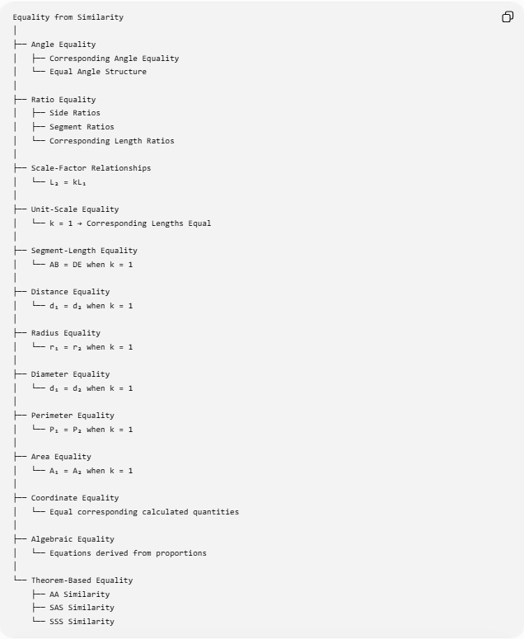
Equality from Similarity
│
├── Angle Equality
│ ├── Corresponding Angle Equality
│ └── Equal Angle Structure
│
├── Ratio Equality
│ ├── Side Ratios
│ ├── Segment Ratios
│ └── Corresponding Length Ratios
│
├── Scale-Factor Relationships
│ └── L₂ = kL₁
│
├── Unit-Scale Equality
│ └── k = 1 → Corresponding Lengths Equal
│
├── Segment-Length Equality
│ └── AB = DE when k = 1
│
├── Distance Equality
│ └── d₁ = d₂ when k = 1
│
├── Radius Equality
│ └── r₁ = r₂ when k = 1
│
├── Diameter Equality
│ └── d₁ = d₂ when k = 1
│
├── Perimeter Equality
│ └── P₁ = P₂ when k = 1
│
├── Area Equality
│ └── A₁ = A₂ when k = 1
│
├── Coordinate Equality
│ └── Equal corresponding calculated quantities
│
├── Algebraic Equality
│ └── Equations derived from proportions
│
└── Theorem-Based Equality
├── AA Similarity
├── SAS Similarity
└── SSS Similarity

Relationship to Geometric Equality
# Source: AI Source: Provided by: [Data Path: Persons Table -> ID Column: 1, Name_En Column: Motasem Essam] -> From: [ChatGPT] on [7/25/2026]
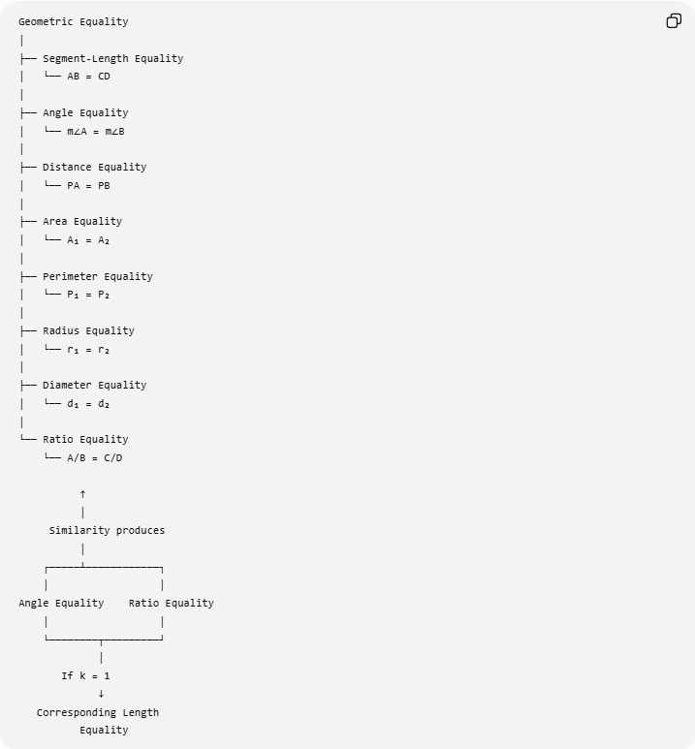
Geometric Equality
│
├── Segment-Length Equality
│ └── AB = CD
│
├── Angle Equality
│ └── m∠A = m∠B
│
├── Distance Equality
│ └── PA = PB
│
├── Area Equality
│ └── A₁ = A₂
│
├── Perimeter Equality
│ └── P₁ = P₂
│
├── Radius Equality
│ └── r₁ = r₂
│
├── Diameter Equality
│ └── d₁ = d₂
│
└── Ratio Equality
└── A/B = C/D

↑
│
Similarity produces
│
┌─────┴────────────┐
│ │
Angle Equality Ratio Equality
│ │
└────────┬─────────┘
│
If k = 1
↓
Corresponding Length
Equality

Key Points
# Source: AI Source: Provided by: [Data Path: Persons Table -> ID Column: 1, Name_En Column: Motasem Essam] -> From: [ChatGPT] on [7/25/2026]
- Similar figures have the same shape but not necessarily the same size.
- Similarity always gives equal corresponding angles:
$$\boxed{∠A=∠A^{'}}.$$
- Similarity gives proportional corresponding lengths:
$$\boxed{\frac{A_{1}B_{1}}{A_{2}B_{2}}=k}.$$
- Similarity does not normally give equal corresponding lengths.
- If:
$$\boxed{k=1},$$
then corresponding lengths are equal.
- Similarity with $k=1$gives congruence in ordinary Euclidean geometry.
- Lengths scale by $k$:
$$L_{2}=kL_{1}.$$
- Perimeters scale by $k$:
$$P_{2}=kP_{1}.$$
- Areas scale by $k^{2}$:
$$A_{2}=k^{2}A_{1}.$$
- Volumes of similar solids scale by $k^{3}$:
$$V_{2}=k^{3}V_{1}.$$
- Ratio Equality is one of the main consequences of similarity.
- AA, SAS, and SSS are standard triangle similarity criteria.

Conclusion
# Source: AI Source: Provided by: [Data Path: Persons Table -> ID Column: 1, Name_En Column: Motasem Essam] -> From: [ChatGPT] on [7/25/2026]
Equality from Similarity describes equal geometric relationships obtained from similar figures.
The most important consequences are:
$$\boxed{\text{Similarity}⇒\text{Equal Corresponding Angles}}$$
and:
$$\boxed{\text{Similarity}⇒\text{Equal Ratios of Corresponding Lengths}}$$
For corresponding lengths:
$$\boxed{\frac{L_{2}}{L_{1}}=k}$$
and only when:
$$\boxed{k=1}$$
do corresponding lengths themselves become equal:
$$\boxed{L_{1}=L_{2}}.$$
For this special case:
$$\boxed{\text{Similarity}+k=1⇒\text{Congruence}⇒\text{Corresponding Equality}}$$
Thus, unlike Equality from Congruence, where corresponding measurements are immediately equal, Equality from Similarity primarily produces angle equality and ratio equality, with actual length, perimeter, radius, diameter, and area equality arising in the special unit-scale case.

